

Year 11 Specialist Mathematics

Test 2 2020

Chapters 3, 4, 5

**Name: Time: 25 minutes Total / 25**

**INSTRUCTIONS:**

**Part A: Non-calculator**

**Notes not allowed**

**Full working must be shown for all questions (or parts) worth more than 2 marks.**

**Marks will be deducted for rounding and unit errors.**

**Question 1 ( 7 marks )**

Given that 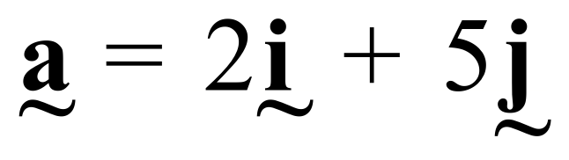 and 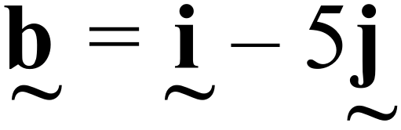 find

a) 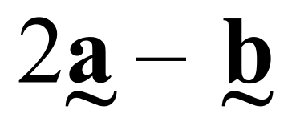 [1]

b)  [1]

c) vector  such that 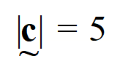 and 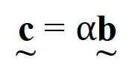 [2]

d) a vector of magnitude 10 moving in the opposite direction to  [3]

**Question 2 ( 5 marks )**

In a triangle ABC, P is the midpoint of BC. Prove that 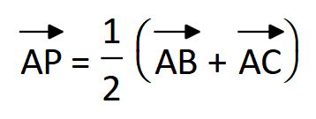

**Question 3 ( 1, 1, 2, 2 = 6 marks )**

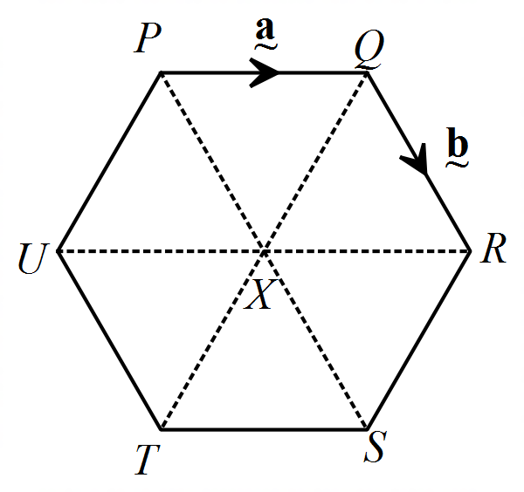PQRSTU is a regular hexagon. If 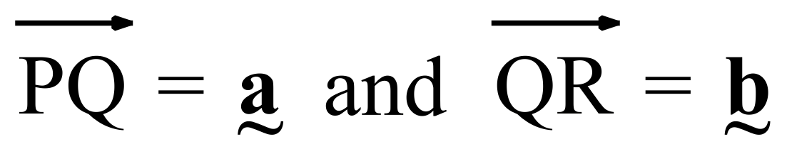, find in terms of  and 

1. 
2. 
3. 

1. 

**Question 4 (3 marks)**

In the diagram 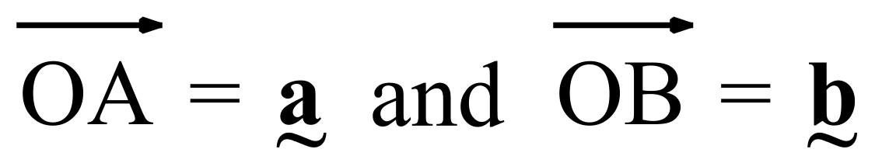 .

Point P divides OA in the ratio OP : PA = 4 : 1.

Point Q divides AB in the ratio AQ : QB = 2 : 3.

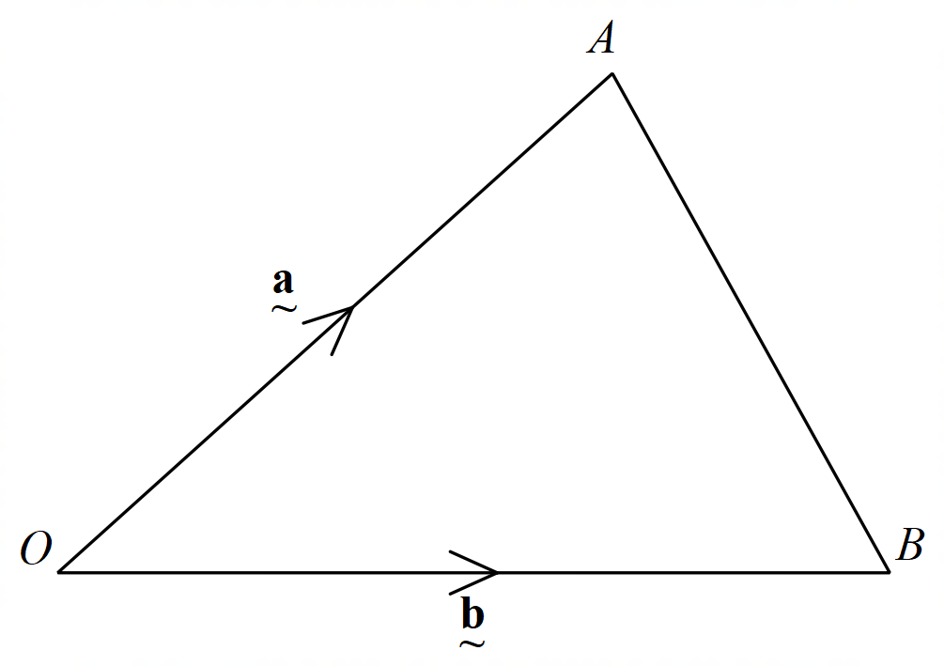Show that 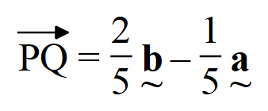

**Question 5 (4 marks)**

Points A, B and C have position vectors 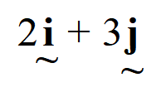 , 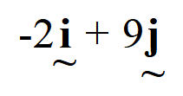 and 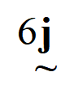 respectively. Use vectors to prove that the points A, B and C are collinear.



Year 11 Specialist Mathematics

Test 2 2020

**Name: _______________________________ Time: 30 minutes Total / 25**

**INSTRUCTIONS:**

**Part B: Calculator allowed**

**1 page of A4 notes allowed**

**Full working must be shown for all questions (or parts) worth more than 2 marks.**

**Marks will be deducted for rounding and unit errors.**

**Question 1 ( 5 marks )**

Find the value of all pronumerals, giving reasons (O is the centre of the circle, AB is a tangent)

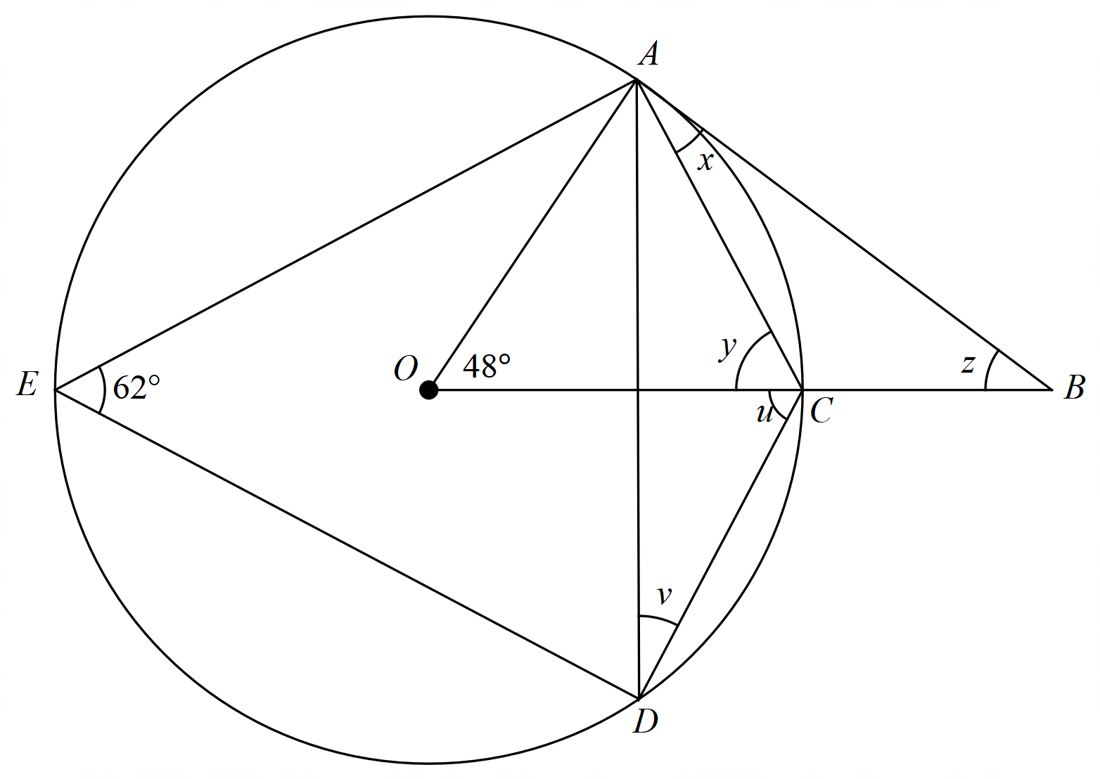

|  |  |
| --- | --- |
| Angle/working | Reason |
|  |  |
|  |  |
|  |  |
|  |  |
|  |  |

Question 2 (3 marks)

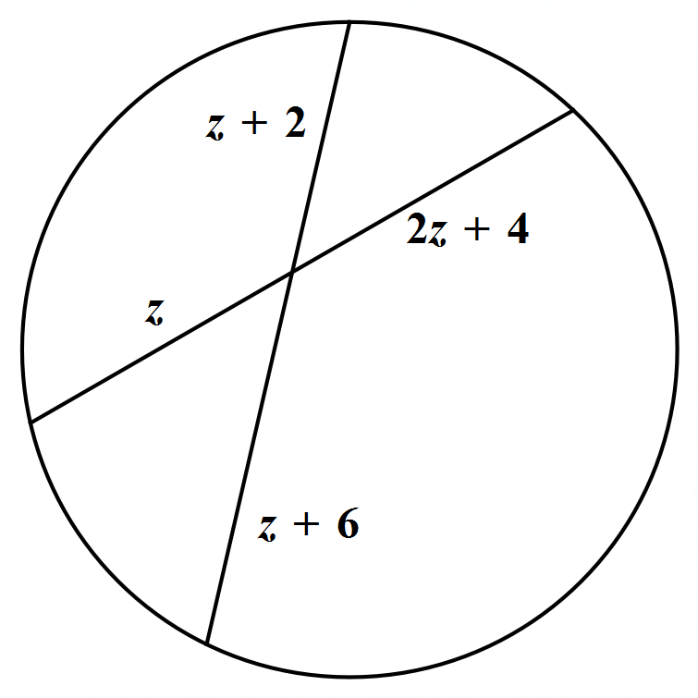Find the value of the pronumeral *z*

**Question 3 (4 marks)**

*GFH* is a common tangent to both circles. Prove that *LK is parallel to NM*

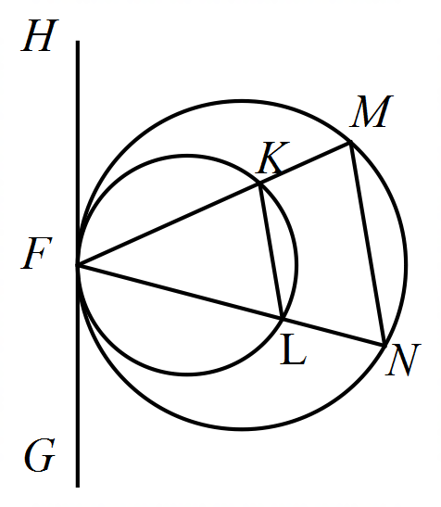

**Question 4 (4 marks)**

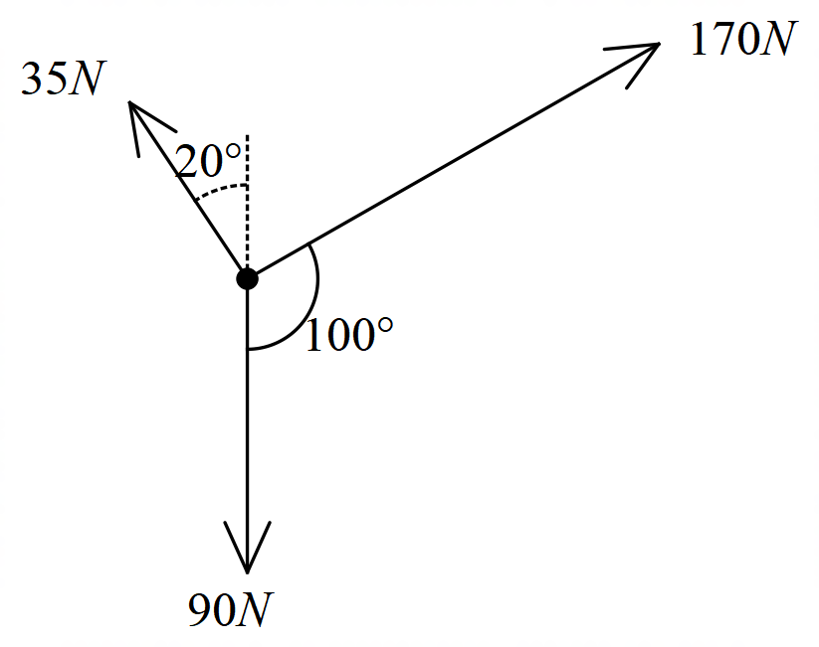Find the resultant of the set of vectors below, giving your answer in the form 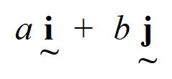

**Question 5 (2, 3 = 5 marks)**

A river of width 100 m where the current flows at 4.5 km/h is shown in the diagram. A boat is to be driven directly across the river from point P to Q. The boat has a speed of 12 k/h in still water.

1. Determine the angle to the bank in which the boat must be directed
2. How long will the journey take?

**Question 6 (5 marks)**

In the diagram below, FCG is a tangent to the circle ABC.

BD bisects 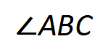 and CD bisects 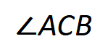

BE bisects 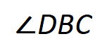 and CE bisects 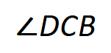

If AB = AC and 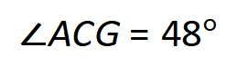 , determine the ratio, in simplest form, of 